3.21: a) The time the quarter is in the air is the horizontal distance divided by the horizontal component of velocity. Using this time in Eq. (3.18),
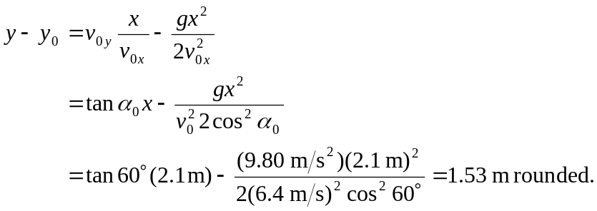

b) Using the same expression for the time in terms of the horizontal distance in
Eq. (3.17),

